UNIT-II
HYDROTHERMAL SCHEDULING
2.1 INTRODUCTION

Most of the power systems are a mix of different modes of generating stations of which the thermal and hydro generating units are predominant. While in some systems hydro generation may be more than thermal generation in some other cases it may be the other way. The operating cost of thermal plants is high even though their capital cost is low.
In case of hydro electric plants, the running costs are very low, but the capital cost is high as construction of dams, canals, penstocks, surge tanks and other elements of development are involved in addition to the power house. The hydro plants can be started easily and can be assigned load in very short time. This is not so in case of thermal plants, as it requires several hours to bring the boiler, super heater, and turbine system ready to take the load allotment. For the reason mentioned, the hydro plants can handle fast changing loads effectively. The thermal plants in contrast are slow in response. For this reason, the thermal plants are more suitable to operate as base load plants, leaving hydro plants to operate as peak load plants.
However, the exact mode of operation depends upon the type of the development, and factors such as storage and pondage and the amount of water that is available is the most important consideration. A plant may be run - off river, run - off river with pondage , storage or pumped storage type.
Whatever, may be the type of plant, it is necessary to utilize the total quantity of water available in hydro development so that maximum economy is achieved. The economic scheduling in the integrated operation is however, made difficult as water release policy for power is subject to a variety of constraints. There are multiple water usages which are to be satisfied. Determination of the so called pseudo - fuel cost or cost for water usage for use in conjunction with incremental water rate characteristic is a formidable exercise. Nevertheless, hydro thermal economic scheduling is possible with assumptions made wherever necessary.
In systems where there is close balance between hydro and thermal generation and in systems where the hydro capacity is only a fraction of the total capacity, it is generally desired to schedule generation such that thermal generating costs are minimized.

2.2 HYDROTHERMAL SCHEDULING IN POWER SYSTEM
Optimal scheduling of power plant generation is the determination of the generation for every generating unit such that the total system generation cost is minimum while satisfying the system constraints. The objective of the hydrothermal scheduling problem is to determine the water releases from each reservoir of the hydro system at each stage such that the operation cost is minimized along the planning period. The operation cost includes fuel costs for the thermal units, import costs from neighboring systems and penalties for load shedding. The basic question in hydrothermal co-ordination is to find a trade-off between a relative gain associated with immediate hydro generation and the expectation of future benefits coming from storage .
Classification of Hydrothermal Scheduling Problem
1. Long range problem
2. Short range problem

2.2.1 Long Range Problem:

Long range problem includes the yearly cyclic nature of reservoir water inflows and seasonal load demand and correspondingly a scheduling period of one year is used. The solution of the long range problem considers the dynamics of head variations through the water flow continuity equation. The co-ordination of the operation of hydroelectric plants involves, of course, the scheduling of water releases. The long-range hydro-scheduling problem involves the long-range forecasting of water availability and the scheduling of reservoir water releases for an interval of time that depends on the reservoir capacities. Typical long-range scheduling goes anywhere from 1 week to 1 year or several years. For hydro schemes with a capacity of impounding water over several seasons, the long-range problem involves meteorological and statistical analysis. The purpose of the long-term scheduling is to provide a good feasible solution that is close to the long-term cost minimization of the whole system. The problem is usually very difficult to solve due to its size, the time span (up to several years) and the randomness of the water inflows over the long term. Long-range scheduling involves optimizing a policy in the context of unknowns such as load, hydraulic inflows and unit availabilities (steam and hydro). These unknowns are treated statistically and long-range scheduling involves optimization of statistical variables.

2.2.2 Short Range Problem:

The load demand on the power system exhibits cyclic variation over a day or a week and the scheduling interval is either a day or a week. As the scheduling interval of short range problem is small, the solution of the short range problem can assume the head to be fairly constant. The amount of water to be utilized for the short-range scheduling problem is known from the solution of the long-range scheduling problem. Short-range hydro-scheduling (1 day to 1 week) involves the hour-by-hour scheduling of all generation on a system to achieve minimum production cost for the given time period. The short term hydrothermal scheduling problem is classified into two groups
1. Fixed head hydro thermal scheduling
2. Variable head hydro thermal scheduling
The factors on which the economic operation of a combined hydrothermal system depends on
1.Load cycle
2. Incremental fuel cost of thermal unit.
3. Expected water inflow in hydropower stations.
4. Water head which is a function of water storage in hydropower stations.
5. Hydro power generation.
6.Incremental Transmission Loss.

2.3Hydroelectric Power Plant Model:
Hydroelectric Power Generation is the oldest and cheapest method. Hydroelectric Power Generation is utilizing the potential energy of water. The energy is obtained almost free of running cost and is completely pollution free. Of course, it involves high capital cost because of the heavy civil engineering construction works involved. Also it requires a long gestation period of about five to eight years as compared to four to six years for steam plants.
Hydroelectric stations are designed, mostly, as multipurpose projects such as river flood control, storage of irrigation and drinking water, and navigation. A simple block diagram of a hydro plant is given in Fig. 2.1. The vertical difference between the upper reservoir and tail race is called the head.
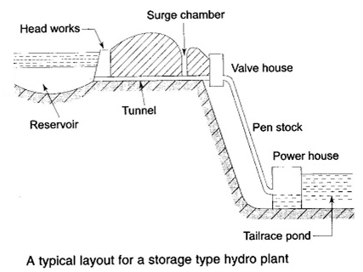
Fig.2.1
Hydro plants are of different types such as run-of-river (use of water as it comes), run-of-river with pondage (medium head) type, and reservoir (high head) type. The reservoir type plants are the ones which are employed for bulk Hydroelectric Power Generation. Often, cascaded plants are also constructed, i.e., on the same water stream where the discharge of one plant becomes the inflow of a downstream plant.
2.4 Short term Hydrothermal Scheduling:
Method of Lagrange Multipliers (losses neglected)
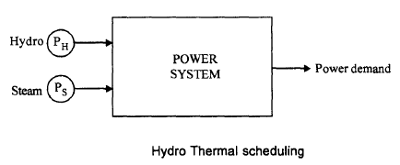
Fig.2.2

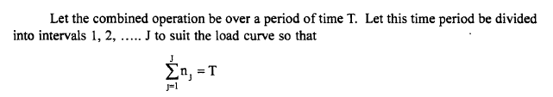
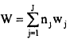......(1)
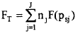.......(2)
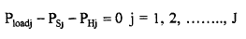.......(3)
The loads are assumed to remain constant during time intervals considered. The total value of water at the beginning and at the end of the interval T, in the reservoir are W_{i} and W _{f} respectively.
During this period of scheduling the head of water is assumed to remain constant.

The input - output characteristic for the equivalent hydro plant is given by
The Lagrange function for minimization of eqn(2) subject to the constraints eqn(1) and eqn(2) is
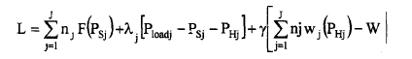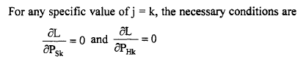
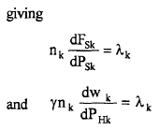
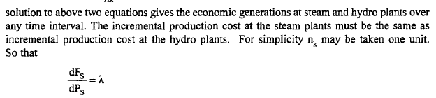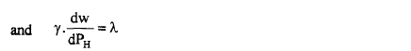
Lagrange Multipliers Method Transmission Losses Considered:
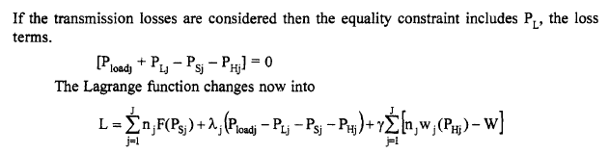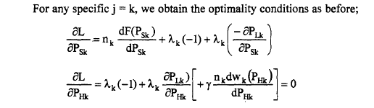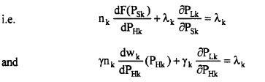
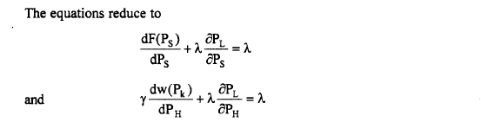
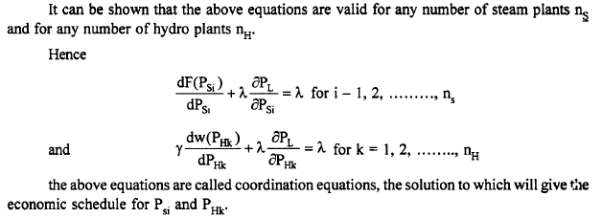
2.5 UNIT COMMITMENT :
Economic dispatch gives the optimum schedule corresponding to one particular load on the system. The total load in the power system varies throughout the day and reaches different peak value from one day to another. Different combination of generators, are to be connected in the system to meet the varying load. When the load increases, the utility has to decide in advance the sequence in which the generator units are to be brought in. Similarly, when the load decreases, the operating engineer need to know in advance the sequence in which the generating units are to be shut down. The problem of finding the order in which the units are to be brought in and the order in which the units are to be shut down over a period of time, say one day, so the total operating cost involved on that day is minimum, is known as Unit Commitment (UC) problem. Thus UC problem is economic dispatch over a day. The period considered may a week, month or a year.
But why is this problem in the operation of electric power system? Why not just simply commit enough units to cover the maximum system load and leave them running? Note that to “commit” means a generating unit is to be “turned on”; that is, bring the unit up to speed, synchronize it to the system and make it to deliver power to the network. “Commit enough units and leave them on line” is one solution. However, it is quite expensive to run too many generating units when the load is not large enough. As seen in previous example, a great deal of money can be saved by turning units off (decommiting them) when they are not needed. Example : The following are data pertaining to three units in a plant.
Unit 1: Min. = 150 MW; Max. = 600 MW
C₁ = 5610 + 79.2 P₁ + 0.01562 P₁² Rs / h
Unit 2: Min. = 100 MW; Max. = 400 MW
C₂ = 3100 + 78.5 P₂ + 0.0194 P₂² Rs / h
Unit 3: Min. = 50 MW; Max. = 200 MW
C₃ = 936 + 95.64 P₃ + 0.05784 P₃² Rs / h
What unit or combination of units should be used to supply a load of 550 MW most economically?
Solution: To solve this problem, simply try all combination of three units.
Some combinations will be infeasible if the sum of all maximum MW for the units committed is less than the load or if the sum of all minimum MW for the units committed is greater than the load.
For each feasible combination, units will be dispatched using equal incremental cost rule studied earlier. The results are presented in the Table below.
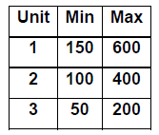
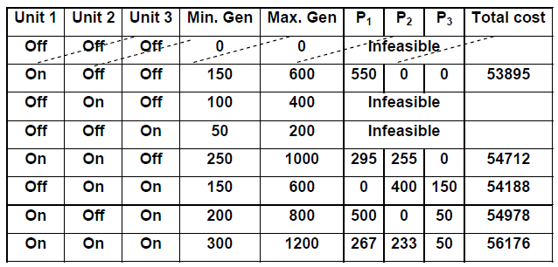
Note that the least expensive way of meeting the load is not with all the three units running, or any combination involving two units. Rather it is economical to run unit one alone.
UC problem become much more complicated when we need to consider power system having several plants each plant having several generating units and the system load to be served has several load steps. So far, we have only obeyed one simple constraint: Enough units will be connected to supply the load. There are several other constraints to be satisfied in practical UC problem.
2.6 CONSTRAINTS ON UC PROBLEM:
Some of the constraints that are to be met with while solving UC problem are listed below.
1. Spinning reserve: There may be sudden increase in load, more than what was predicted. Further there may be a situation that one generating unit may have to be shut down because of fault in generator or any of its auxiliaries.
Some system capacity has to be kept as spinning reserve
i) to meet an unexpected increase in demand and
ii) to ensure power supply in the event of any generating unit suffering a forced outage.
Spinning Reserve= Total amount of generation available from all the units synchronized on the system - the load demand- Transmission losses
2. Minimum up time: When a thermal unit is brought in, it cannot be turned off immediately. Once it is committed, it has to be in the system for a specified minimum up time.
3. Minimum down time: When a thermal unit is decommitted, it cannot be turned on immediately. It has to remain decommitted for a specified minimum down time.
4. Crew constraint: A plant always has two or more generating units. It may not be possible to turn on more than one generating unit at the same time due to non-availability of operating personnel.
5. Transition cost: Whenever the status of one unit is changed ,some transition cost is involved and this has to be taken into account.
6. Hydro constraints: Most of the systems have hydroelectric units also. The operation of hydro units, depend on the availability of water. Moreover, hydro-projects are multipurpose projects. Irrigation requirements also determine the operation of hydro plants.
7. Nuclear constraint: If a nuclear plant is part of the system, another constraint is added. A nuclear plant has to be operated as a base load plant only.
8. Must run unit: Sometime it is a must to run one or two units from the consideration of voltage support and system stability.
9. Fuel supply constraint: Some plants cannot be operated due to deficient fuel supply.
10. Transmission line limitation: Reserve must be spread around the power system to avoid transmission system limitation, often called “bottling” of reserves.
2.7 Solution Methods for unit commitment Problem
(i) Exhaustive enumeration method
(ii) Priority list method
(iii) Dynamic Programming method(DP)
(Forward Dynamic Programming method )
(i) Exhaustive enumeration method:
The unit commitment has been solved by enumerating all possible combinations of generating units and then the combination that yields the least operating cost is chosen as the optimal solution. This method is capable of providing an accurate solution but it is not suitable for large sized plants.
(ii) Priority list method:
From the modeling point of view the priority list method is the simplest method. The priority list method initially arranges the generating units based on the lowest operating cost( A unit having lowest operating cost is given as Rank 1, the unit having next lowest operating cost is given as Rank 2, and up to the unit having Highest operating cost).
The predetermined order is used for unit commitment such that the system load and reserve requirements are satisfied for every hour. The calculation time for this method is small even for large size plants. The disadvantages of this method is that it is not considered to be accurate and also state transition costs are not taken in to account. Hence this method is modified to give better solution which is known as Advanced priority list method.
Advanced priority list method:
In order to improve the accuracy of priority list method a new method is proposed called advanced priority list method. In this method the units in a power plant are divided in to separate groups.
They are (1) Must run group (2) Test group (3) Peak group.
The units are selected in sequence in order to meet the total demand and reserve.
Priority list method Example:
In this method the full load average production cost of each unit is calculated first. Using this, priority list is prepared.
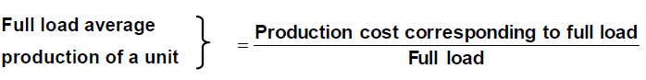
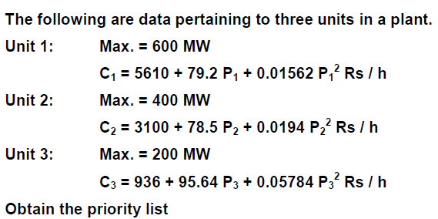

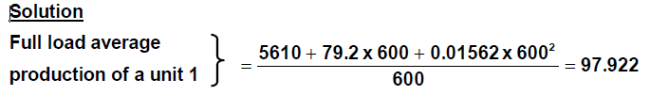
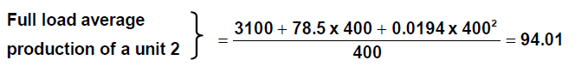
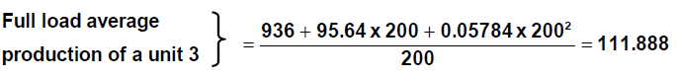
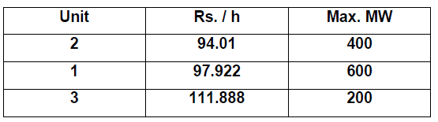
The shutdown scheme would (ignoring min. up / down time, start – up costs etc.) simply use the following combinations.
Combination Load PD
2 + 1 + 3 1000 MW ≤ PD < 1200 MW
2 + 1 400 MW ≤ PD < 1000 MW
2 PD < 400 MW
With the priority – list scheme both units would be held on until load reached 400 MW, then unit 1 would be dropped.

Algorithm for priority list method:
Most priority schemes are built around a simple shut – down algorithm that might operate as follows:
Step 1: At each hour when the load is dropping, determine whether dropping the next unit on the priority list will leave sufficient generation to supply the load plus spinning reserve requirements. If not, continue operating as is; if yes, go to next step.
Step 2: Determine the number of hours, H, before the unit will be needed again assuming the load is increasing some hours later. If H is less than the minimum shut – down time for that unit, keep the commitment as it is and go to last step; if not, go to next step.
Step 3: Calculate the two costs. The first is the sum of the hourly production costs for the next H hours with the unit up. Then recalculate the same sum for the unit down and add the start – up cost. If there is sufficient saving from shutting down the unit, it should be shut down; otherwise keep it on.
Step 4: Repeat the entire procedure for the next unit on the priority list. If it is also dropped, go to the next unit and so forth.
Dynamic Programming Method
